**Install and run ICE testing scripts on Windows 10 OS:**

1. Go to this link: <https://www.python.org/downloads/windows/>

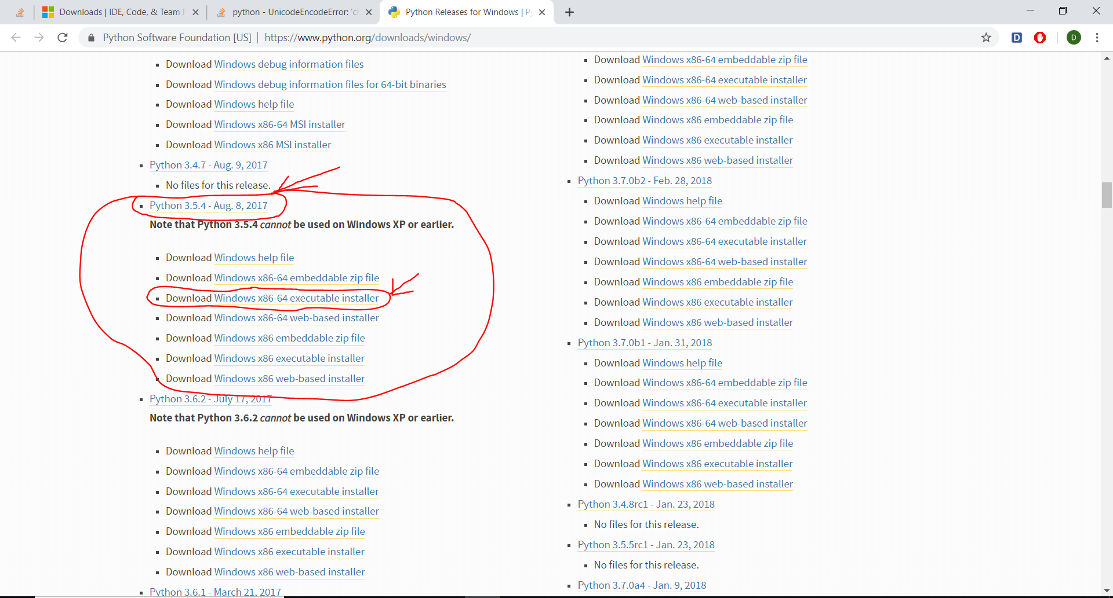

From option **Python 3.5.4 - Aug. 8, 2017** chose **Download Windows x86-64 executable installer**

Run downloaded exe file (python-3.5.4-amd64.exe) to install Python.

Click **Customize installation.** Then click **Next**

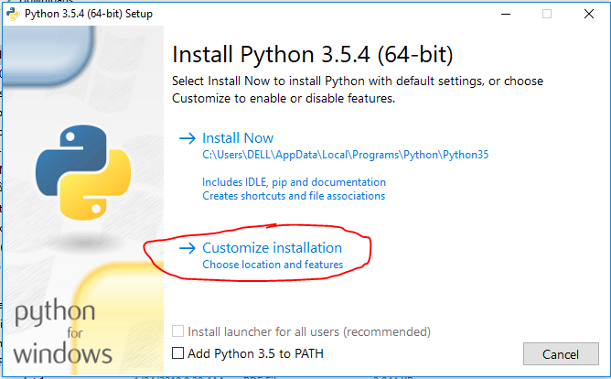

**Set location is: C:\Python3 and click Install**

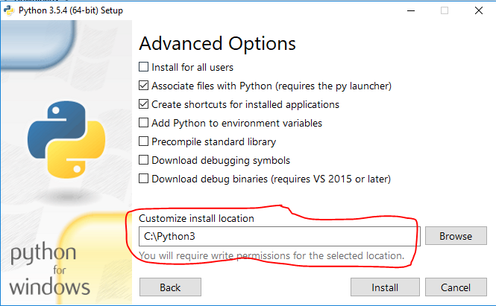

1. Search **Control Panel** and open it.

In the search bar, search for ‘**Variable Environment**’ and click on **Edit the System environment variables**.

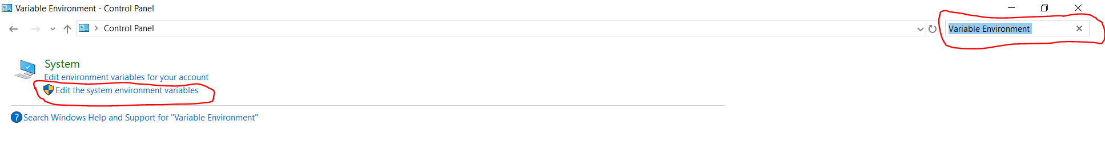

Click on **Environment Variables**..

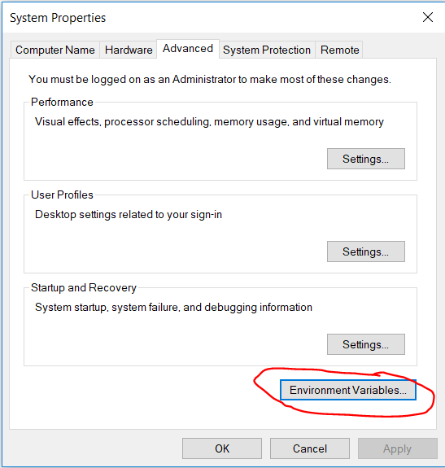

Click on **Path**, click on **Edit**.

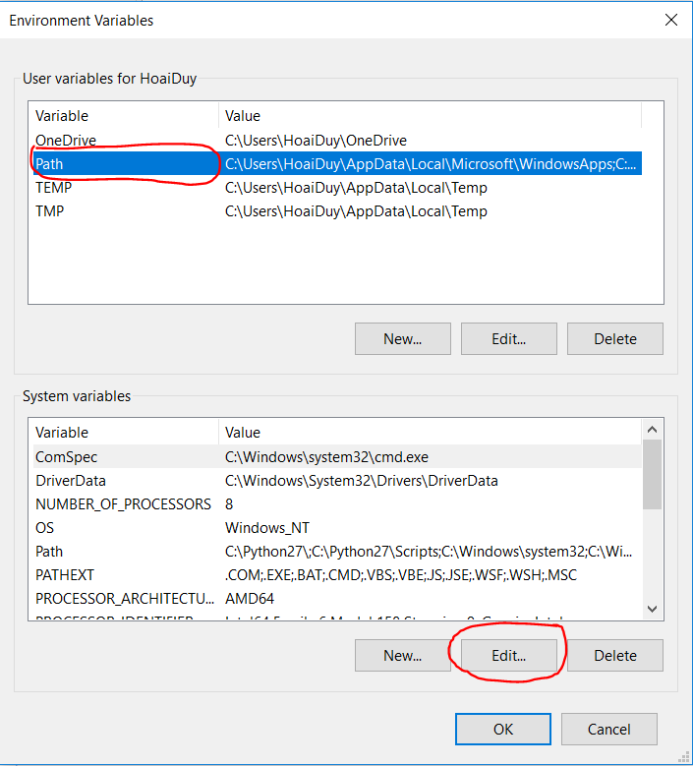

Click on **New** and add the following path in order to use python3 and pip3.

**C:\Python3**

**C:\Python3\Scripts**

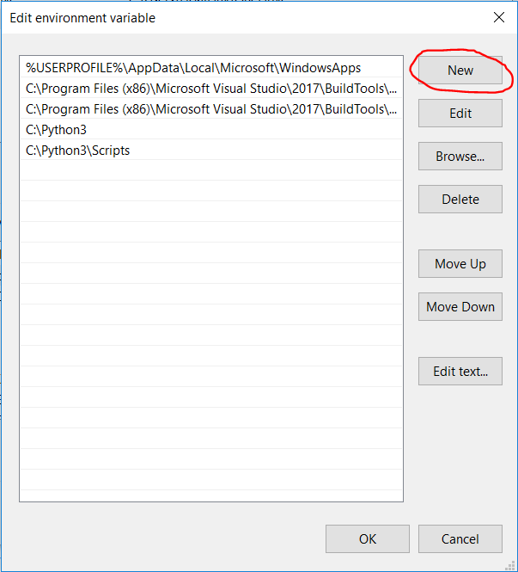

Click on **OK**, **OK**, **OK** to update modification.

Change python.exe to python3.exe where python3 is located (C:\Python3)

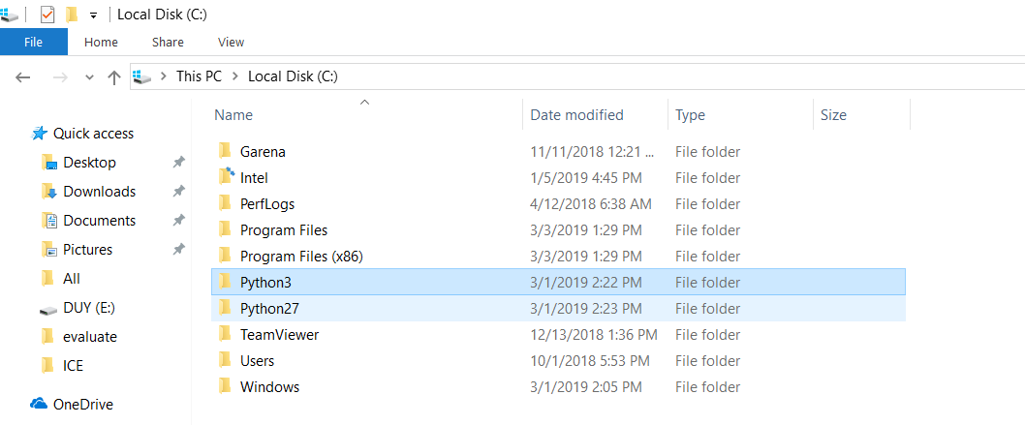

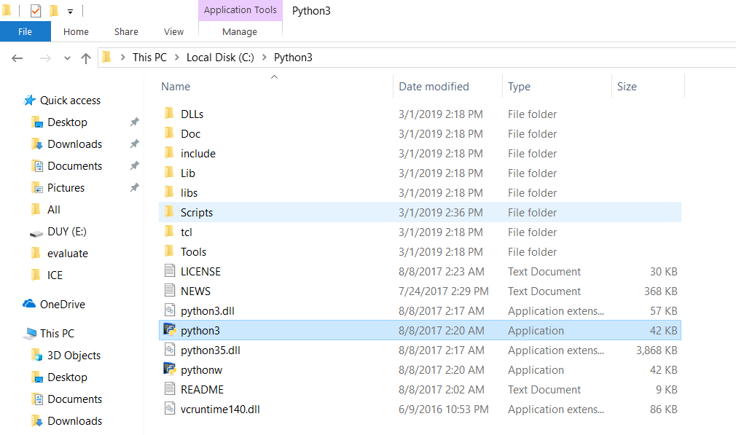

1. Go to this link: [https://visualstudio.microsoft.com/downloads/#build-tools-for-visual-studio-2017](https://visualstudio.microsoft.com/downloads/" \l "build-tools-for-visual-studio-2017)
2. Select free download Build Tools for Visual Studio 2017. This will download the installer. Run the installer.

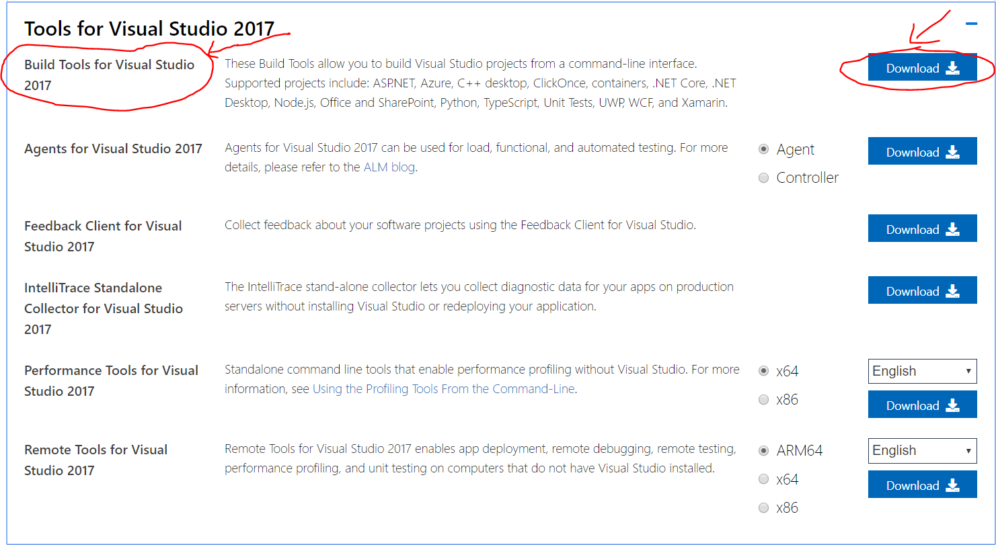

1. Under Windows, there are 3 choices. Only check Visual C++ build tools

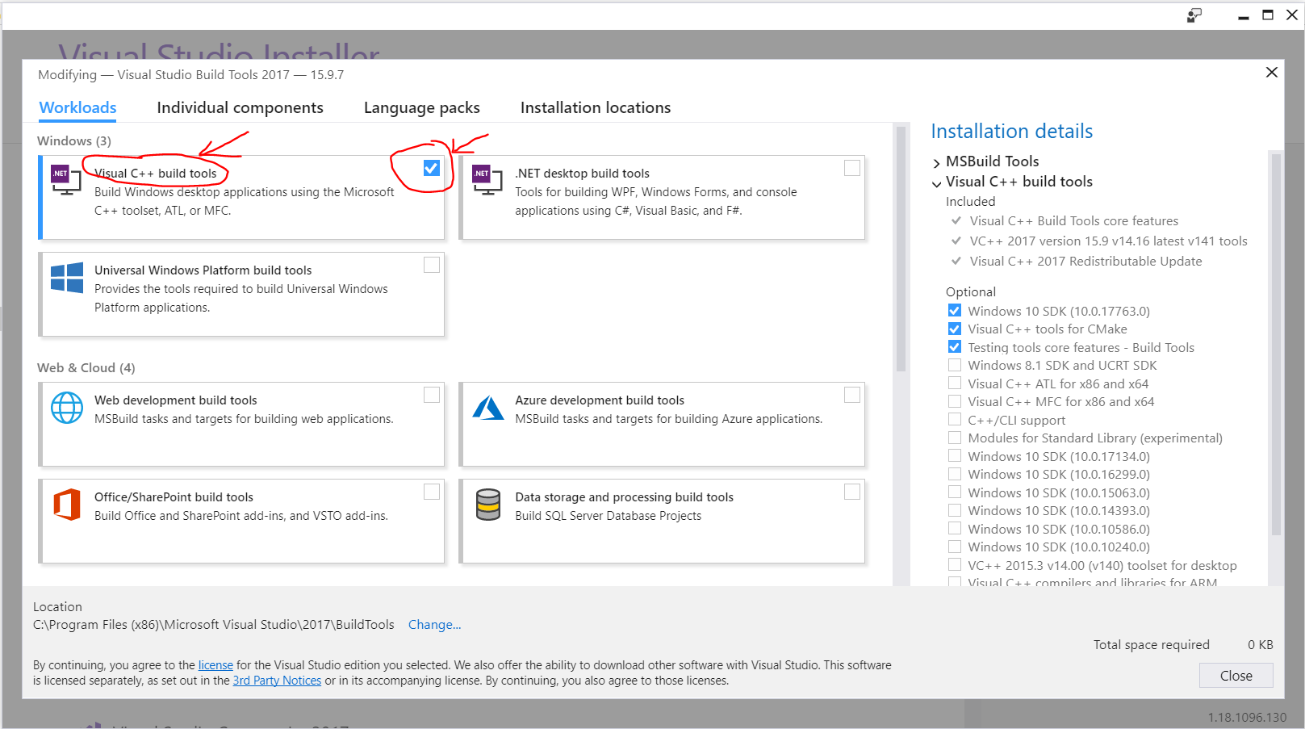

Click **Install**

1. Run fie: ICE_installer.bat
2. Activate environment. In cmd, type: ICEenv\Scripts\activate
3. Change current directory working to ICE\evaluate
4. Display UTF-8 on Windows command prompt. In cmd, type: chcp 65001
5. Run ICE test scripts. In cmd, type: python3 evaluate.pyc data.json